Dexcom G6 and G7 Non-Touchscreen Receivers URGENT MEDICAL DEVICE CORRECTION - CUSTOMER CARE TALK TRACK

Background Information: On June 12, 2025, CVS Health received an updated Urgent Medical Device Correction from Dexcom, Inc. for Dexcom G6 and G7 Receivers. CVS Health received the previous Urgent Medical Device Correction from Dexcom, Inc. on May 14, 2025.

This Urgent Medical Device Correction was issued because of an issue where alarms/alerts may not function as designed. In such instances, the alarm/alert may not provide audio output when an audio prompt would be expected.

This Urgent Medical Device Correction Update applies ONLY to users of Dexcom Receivers with a part number listed in Table 1 below. Users of a receiver with a part number listed in Table 1 should check the receiver serial number to find out if their receiver is affected by this issue. See Image 4 below for details on where you can find the part number and serial number for the receiver.

Table 1: Products Affected
Part Number | NDC/Number | SKUs | Part Description
MT27408-1 | 08627-0091-11 | STK-FM-001 STK-FR-001 | Dexcom G6 Receiver
MT26403-0 | 08627-0078-01 | STK-AT-011 STK-AT-012  STK-AT-013 | Dexcom G7 Receiver

An impacted receiver will still provide an alert through vibration and visual prompts. Other receiver and system functions, including accuracy, are not impacted and there is no impact to Dexcom sensors or applications.

A missed or delayed alarm/alert could potentially result in missed detection or treatment of severe hypoglycemia or hyperglycemia.

Dexcom has assessed that it is necessary to conduct an Urgent Medical Device correction to remind users to check their systems regularly in accordance with their instructions for use.

Customer Care Talk Track:

** Please ensure to disposition all recall calls to code “1116” **

Q# | Question | Action | Answer
1 | I heard that there is an Urgent Medical Device Correction with my Dexcom G6 or G7 Receiver. Can you give me more information? | Note: Check PeopleSafe to determine if the medication is from Mail or Specialty Pharmacy | If the medication was dispensed from… | Then say…
1 |  |  | Mail Order | - Yes, I can.  - Proceed to Q2
1 |  |  | Specialty | While in PeopleSafe, determine the phone number of the dispensing Specialty pharmacy and transfer the call.  A: Yes, I can. Please hold while I transfer you to your Specialty Pharmacy.

Customer Care/Specialty Talk Track Clinical Care Service/Specialty Pharmacy Talk Track
2 | Why is there an Urgent Medical Device Correction? What is wrong with the product? |  | This Urgent Medical Device Correction was issued because of an issue where alarms/alerts may not function as designed. In such instances, the alarm/alert may not provide audio output when an audio prompt would be expected.  For more information, call Dexcom Technical Support toll-free at 1-844-478-1600. Technical Support is available 24 hours a day, 7 days a week. You may also call the United States Food and Drug Administration (FDA) toll-free at 1-888-INFO-FDA (1-888-463-6332) or visit www.fda.gov.
3 | May I return the Dexcom G6 or G7 Receiver that I have? | Determine if the patient is affected by this Urgent Medical Device Correction. | First, let’s determine if you are affected by this Urgent Medical Device Correction:
3 | May I return the Dexcom G6 or G7 Receiver that I have? |  | If the product was dispensed in… |  | Then say...
3 | May I return the Dexcom G6 or G7 Receiver that I have? |  | Manufacturer’s Package |  | - Verify if your receiver is affected by this issue: Check the serial number for any receiver(s) you use, with a part number listed in Table 1, by visiting this webpage:  https://dexcom.com/en-us/checkreceiver  - If you need assistance with the serial number verification process, please contact Dexcom Technical Support at 1-844-478-1600.  - If your product is not from this affected part number, it is not affected by this issue.  If your product is from this affected part number:  - Contact Dexcom Technical Support at 1-844-478-1600 to coordinate return of the affected receiver and a no charge replacement.  Whether or not your receiver is affected by this notification, Dexcom continues to recommend regular testing of the speaker. Test speaker function every time you charge your receiver. When you charge, a reminder prompt will invite you to test speaker function. See Reference Images 1-3 below.  - Electively test the receiver speaker at any point through the menu:  Menu>Information>Receiver> Speaker>Test  - If a speaker test is not successful, contact Dexcom Technical Support at 1-844-478-1600. If a speaker test is successful, continue to test speaker function regularly.

Reference Images:

Image 1: Receiver Speaker Test

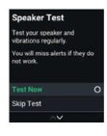

Image 2: User Guide Excerpt – G6

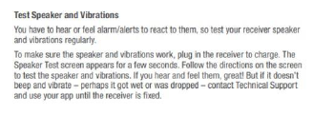

Image 3: User Guide Excerpt – G7

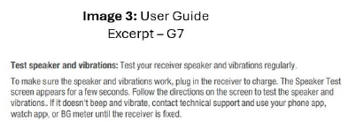

Image 4: Examples of Affected Receiver

- Note: The part number and serial number are both listed on the back of the receiver as shown in the image to the right/below:
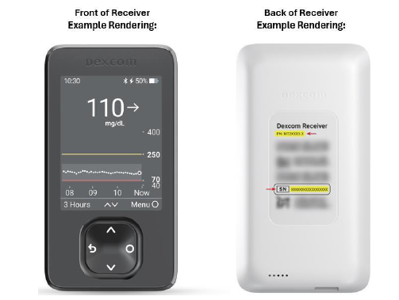

Top of the Document

Not To Be Reproduced Or Disclosed to Others Without Prior Written Approval
ELECTRONIC DATA = OFFICIAL VERSION / PAPER COPY = INFORMATIONAL ONLY

